Chest X-ray
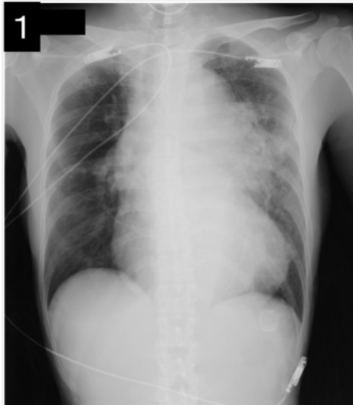
PATIENT INFORMATION:
- Age: Not specified (adult)
- Gender: Not specified

CLINICAL INDICATION:
Shortness of breath, palpitations

FINDINGS:
Heart size remains slightly large. Aorta remains tortuous. Pulmonary markings remain normal. No infiltrates or masses in the lungs. No evidence of pneumonia.

IMPRESSION:
Continued slight cardiomegaly with no evidence for failure or pneumonia.

ADDITIONAL NOTES:
Cardiothoracic ratio: 67%
Congestion in both lungs noted in some cases [citation:10]

